**Assignment - 1**

|  |  |
| --- | --- |
| **Student Name/ID Number:** | W.A. Chathushi Dilhari Jayarathna |
| **Unit Number and Title:** | Uni 01 / Front End Web Development |
| **Academic Year:** | 2022/23 |
| **Unit Assessor:** |  |
| **Project Title:** | Information Architecture, Wireframe and Story Board (ABC Learning Center) |
| **Issue Date:** | 04/04/2022 |
| **Submission Date:** | 18/04/2022 |
| **Internal Verifier Name:** |  |
| **Date:** | 12/04/2022 |

|  |
| --- |
| **Learner declaration** |
| I certify that the work submitted for this assignment is my own and research sources are fully acknowledged.  Student signature: Chathushi Date: 18/04/2022 |

**Project Overview and Objective**

|  |  |
| --- | --- |
| **Application / Site Name:** | **ABC Learning Center** |
| Business Goal | * Increase new courses followers reviews by 30% year over year * Increase course fee by 4% over the next four months * Increase student’s enrollment by 60% within six months * Develop and launch three new courses. * Open new centers locations throughout the Sri Lanka |
| User Goals | * Ensure that learners can obtain copies of their own (and only their) records on a timely manner. * To learn more about the recognition of certification. * To check for Institute’s contact details. * To check who are the mentors teaching and their qualifications for each other. * To getting clear understand of courses structures and lectures. |
| What problems are we solving? | * The institute’s name is not reaching expected audience. * Users are not well informed about the courses offered by Institute. |
| What does your website do? | * Allow users to access information on the institute. * Help users to find new courses information. |
| How does your concept improve the user’s current way of doing the task? | * The website is designed in a way such that all the available courses and schedules |
| What are the key features? | * Well planned Information Architecture * Availability of achievements |

**User Persona**

|  |  |  |
| --- | --- | --- |
| **Persona Type** | **Reason for visit** | **Expectations** |
| **School Leavers** | - Find courses after A/Ls Examination  - To check information about courses. | To find best path for future. |
| **University Students** | -Find course that can follow in weekends.  -Upgrade themselves | To get Job |
| **Parents** | To check information about courses and institute. | To see the courses and institute is good for their child. |

**Content Classification & Sorting**

**Navigation**

* Home
* About Us
* Contact Us
* Courses
* Site Map
* Sign In
* Privacy Policy

**Footer**

* Email
* Contact Numbers
* Address
* Payment Methods
* Social Media Accounts

**Home Page**

* Logo and the Center Name
* Welcome Message
* Images
* Highlights
* Existence and success story
* Online chats
* Hotline
* Useful Links

**About Us**

* Logo and the Center Name
* About us
* Images
* Who we are?
* Our Mission
* Our Vision
* History
* Our Goals
* Our Objectives
* Meet our Leaders

**Contact us**

* Logo and Center Name
* Send Message
* Phone No, Email, Fax, Hotline
* Location Map

**Course Details**

* Logo and Center Name
* Programming in Java
* Programming in .Net
* Html
* Course Image

**Programming in Java**

* Logo and Center Name
* Program Overview
* Course Images
* Course Schedule
* Department, Center, Level & Duration
* Apply Online

**Programming in Java Schedule**

* Logo and Center Name
* Time table
* Images

**Programming in .Net**

* Logo and Center Name
* Program Overview
* Course Images
* Course Schedule
* Department, Center, Level & Duration
* Apply Online

**Programming in .Net Schedule**

* Logo and Center Name
* Time table
* Images

**Site Map**

* Page Links

**Privacy Policy**

* Logo and Center Name
* Data Policy
* Open Educational Resource Policy
* Green Policy

**Information Architect**

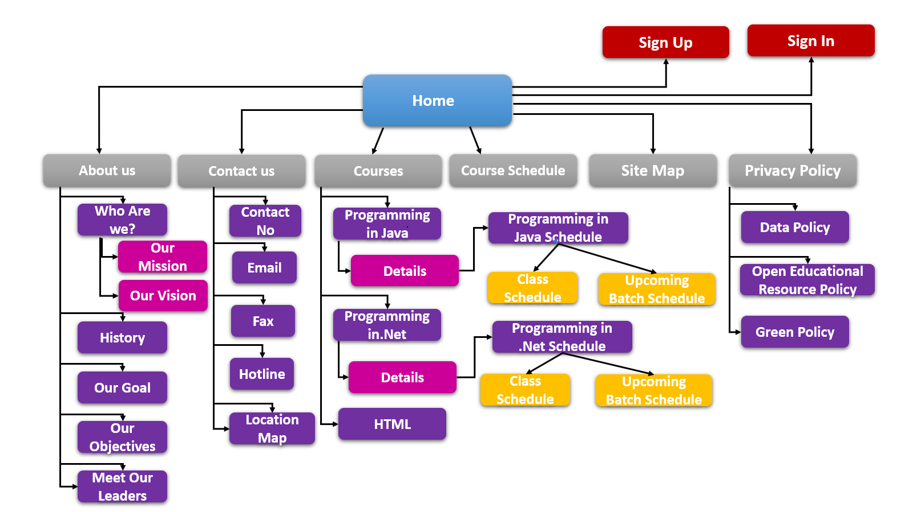

**Wireframe**

**Screen 1 – Home**

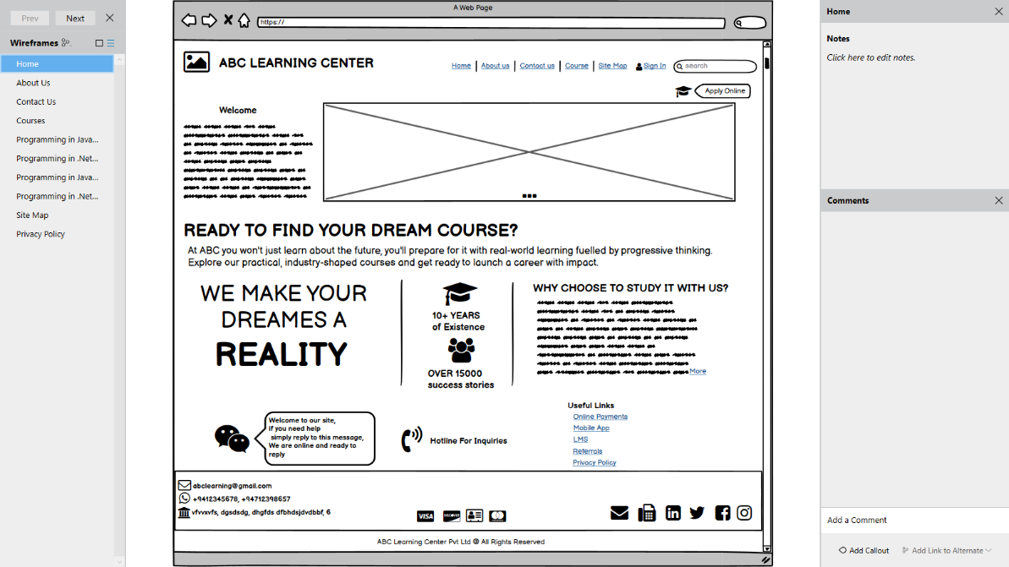

**Screen 2 – About Us Page**

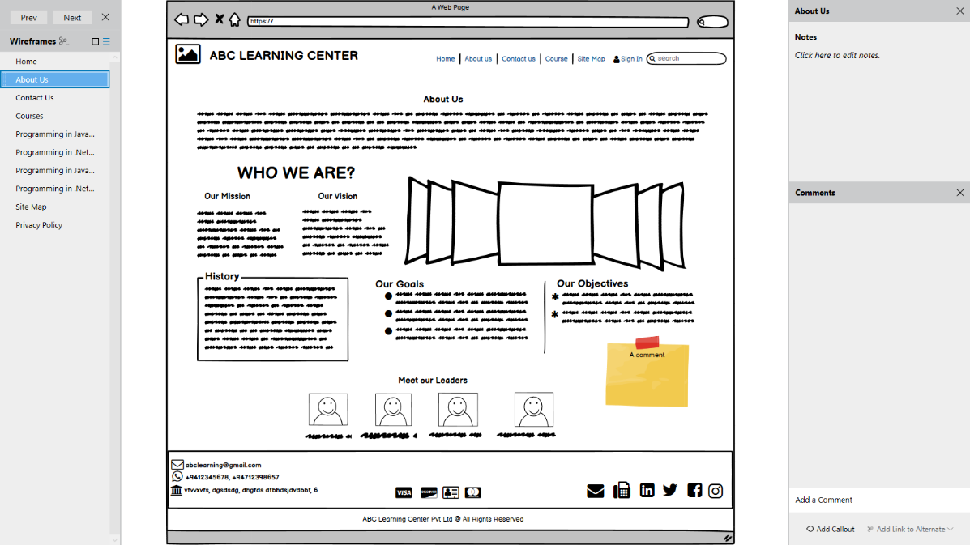

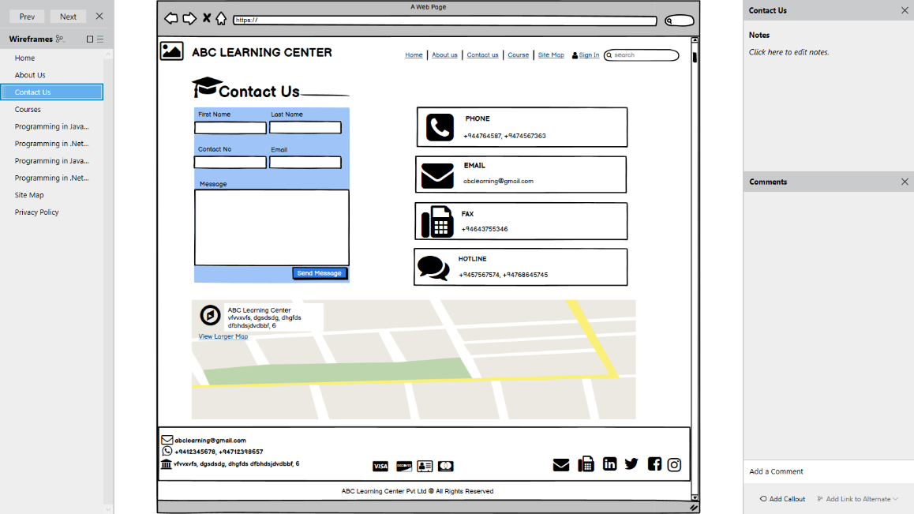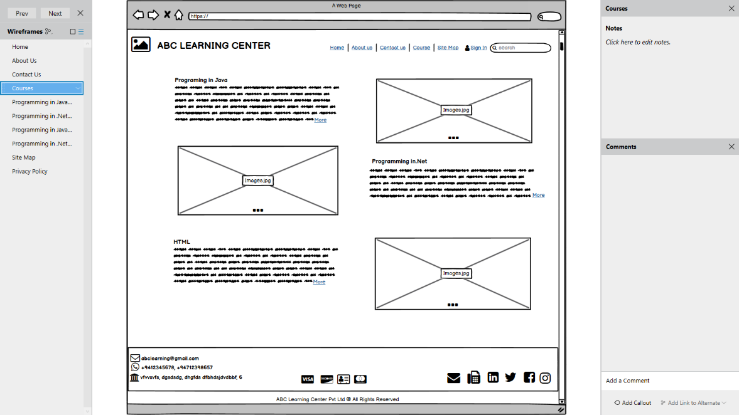**Screen 3 – Contact Us Page**

**Screen 4 – Courses Page**

**Course Details Pages**

**Screen 5 – Programming in Java**

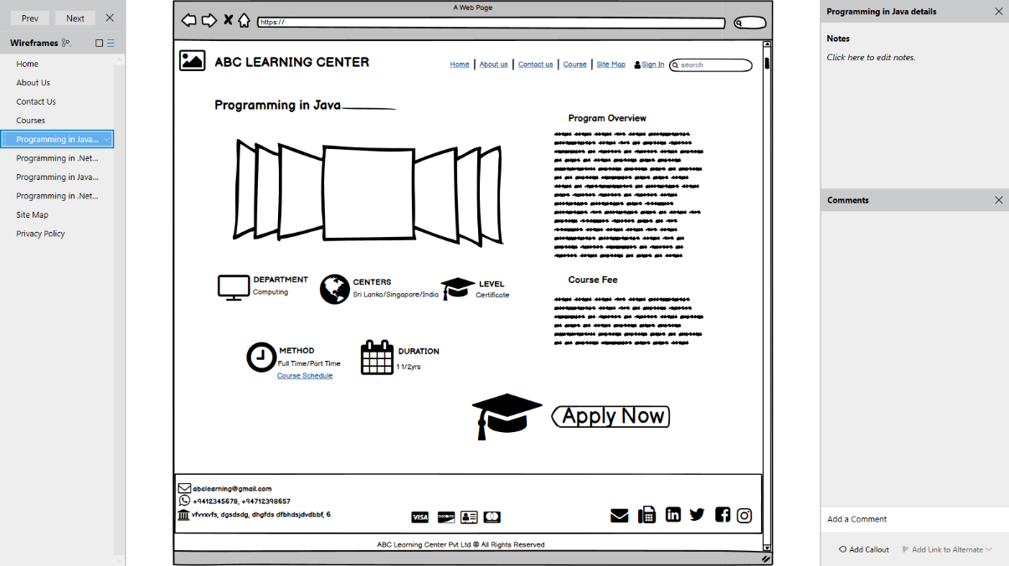

**Screen 6 – Programming in .net**

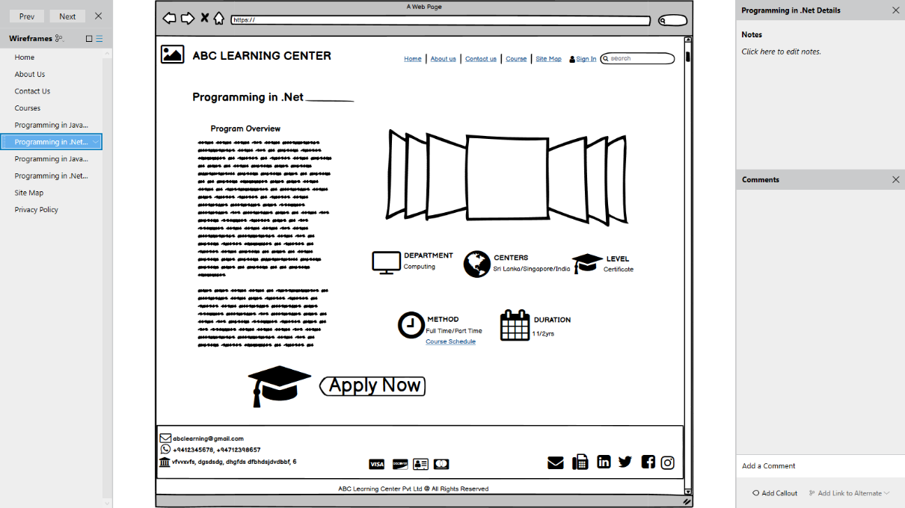

**Course Schedule Pages**

**Screen 7 – Programming in Java**

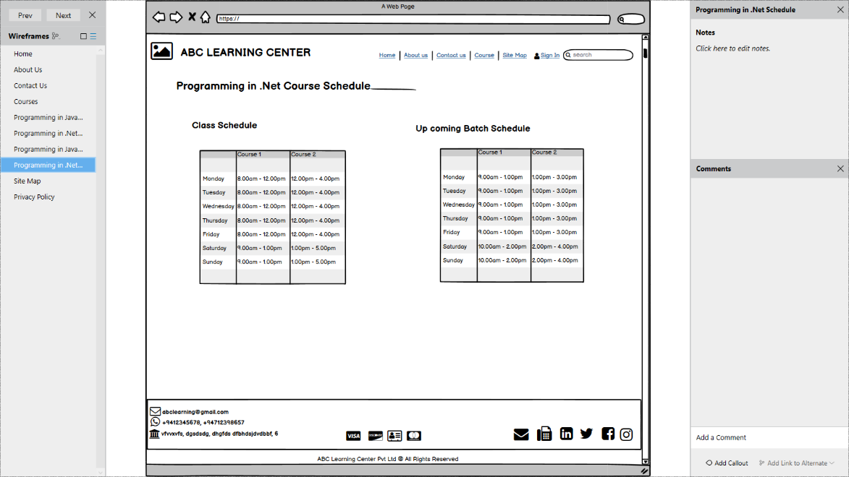

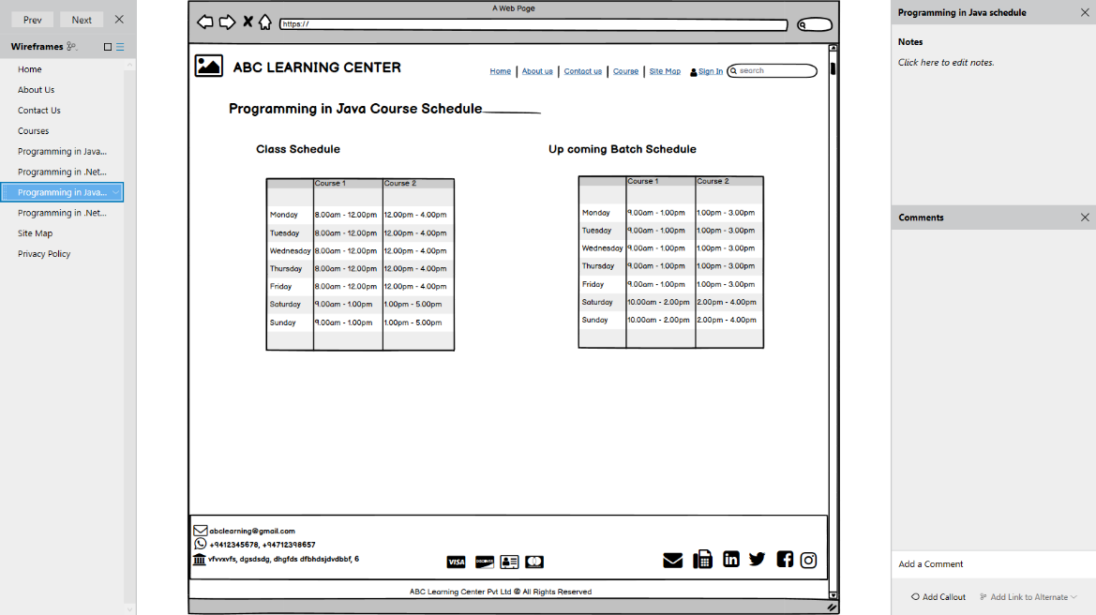**Screen 8 – Programming in .Net**

**Screen 9 – Site Map**

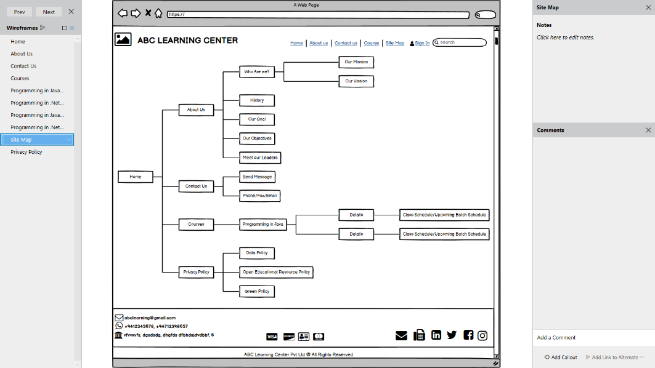

**Screen 10 – Privacy Policy**

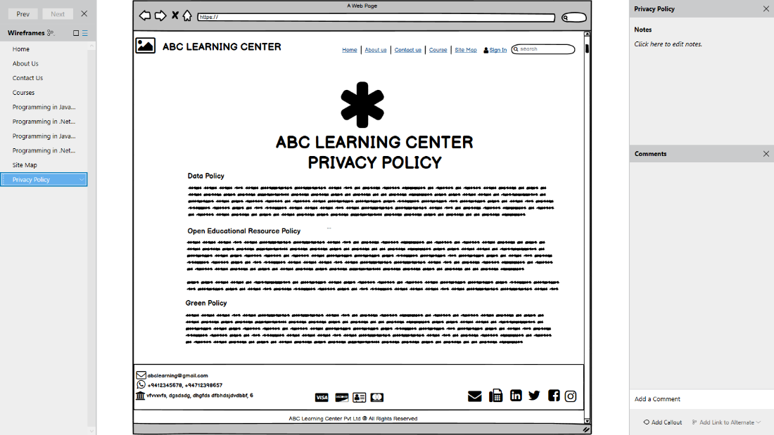

**Storyboard**

